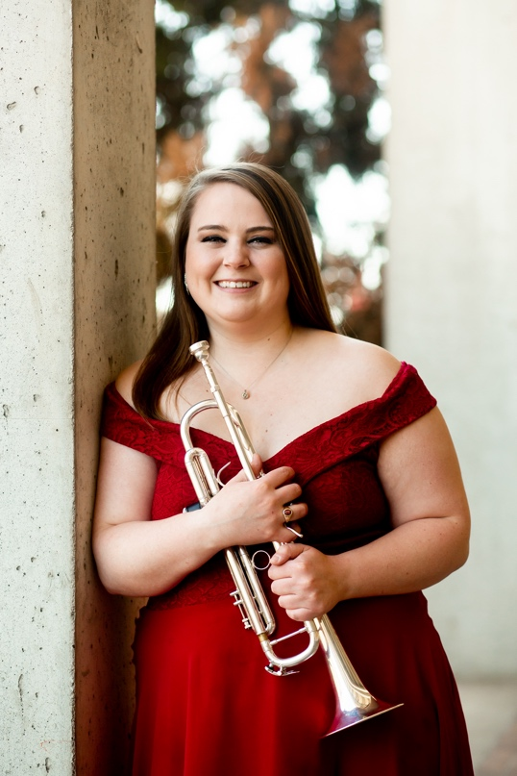
About the Teacher
Ms. Bartleman is a native of Des Moines, Iowa and entering her first of teaching at Roosevelt High School. Prior to this role, she worked as a substitute teacher with the Special School Districts of Saint Louis. During her graduate studies at Southern Illinois University, Ms. Bartleman was a graduate teaching assistant for the Athletic Bands, including the Marching Salukis and SIU Pep Band. As an accomplished musician, she has performed in a wide variety of ensembles, including wind ensemble, orchestra, jazz band, musicals, and chamber music. Ms. Bartleman resides in Saint Louis with her significant other and her two cats, Felix & Ella.
- Bachelor of Arts – Luther College, Music (2021)
- Master of Music – Southern Illinois University Carbondale, Trumpet Performance and Pedagogy (2023)
- Master of Education – University of Missouri Saint Louis, K-12 Instrumental Music Education (anticipated 2026)
Contact Information
Name: Ms. Rachel Bartleman
Email: Rachel.Bartleman@slps.org
Phone Number: (314) 776 – 6040
Room: 111/Auditorium

About the Course
Course Description
This course is for interested students in grades 9-10 who have had little or no experience on a wind instrument. Topics include fundamental techniques of embouchure and fingerings, care of instrument, ensemble playing, and vocabulary of the discipline.
Required Materials
- Band Instruments (Provided)
- Instrument Care Supplies (Limited availability)
- Music Folder (Provided)
- Pencil

Attendance
Attendance is mandatory for all rehearsals and performances. If a student misses a performance, their grade will drop down one letter grade (A to B, B to C, etc.). Two missed performances will result in an automatic F for the course. For daily attendance policies, please reference the Student Handbook.

Grading
Points Breakdown
- Daily Attendance: 3 Points each day
Come to rehearsal– 1 point
Actively engaged in rehearsal – 2 points
- Daily Stations: 5 Points each day
- Performances: 20 points each
Grading Scale
- A: 100 – 90
- B: 89 – 80
- C: 79 – 70
- D: 69 – 60
- F: 59 and below
Class Expectations
- Be respectful, responsible, courteous, and kind
- No inappropriate language
- No talking during instruction
- No food, drink, or chewing gum
- No cell phones or personal technology (headphones, personal laptops)
- Do not touch Smart Board or extra supplies without permission
- No hoods up (must be able to see ears)
- No vandalism (drawing on the walls, ripping down decorations)
- Do not open window blinds
- Do not touch other people’s belongings
- Clean up your own mess
- If a student borrows something from the teacher, they must give something as collateral
Class Procedures
- Students must enter the classroom before the bell rings. Once the bell rings, the classroom door will be locked, and students must have a valid hall pass to enter
- Daily agenda will be posted to the Smart Board for students to review as they enter the classroom.
- The first 10 minutes of class will be allotted for the students to do the following:
  - Getting out instruments and music folders
  - Sit in assigned seats
  - Assemble instruments
  - Individual warm up
- When the teacher stands on the podium, all students are to stop playing and wait for further instructions.
- During rehearsal, all students must actively participate and be engaged in what is happening. No side conversations or sleeping.
- If a student needs to leave during class, they need to have a valid hall pass. See student handbook for further details. Only one student is out of the room at a time.
- At the end of the rehearsal, the last 5 minutes of class will be allotted for students to put away all instruments, music binders, and other supplies. Once a student has completed packing up and put away their belongings, they are to sit in their assigned seats until the bell rings. No students are to line up at the door.
- If a student needs extra supplies or equipment, they need to ask the teacher.
Music Equipment
Instruments
- Students will be assigned a school-owned instrument to be used for the school year (wind instruments only, percussion equipment is provided)
- Prior to receiving an instrument, students are to fill out an “Instrument Checkout” form and turn back in to Ms. Bartleman
- All band instruments are not to leave Roosevelt grounds at any time
- It is the responsibility of the student to take care of instrument and reporting any damages
- If an instrument needs to be taken to the music store for repairs, the school will provide an extra instrument based on availability.
- Excessive damage or neglect of an instrument will result in a fine to cover the cost of repairs
- Any additional questions regarding instruments should be directed to Ms. Bartleman
Care Supplies
- Due to the limited availability of supplies, all students are to provide their own care supplies for their school instruments.
- These items can be purchased through Nottelmann Music or Amazon
- See Ms. Bartleman’s site on the Roosevelt High School website for further information
Music Folders
- Students will be assigned a music folder number. These folders are not to leave school at any point. All copies of music will be available for students to look over at home on Teams.
- Any music folders missing at the end of the year will result in a $5.00 fine to cover cost of replacement of folder and music inside
Performances
- Throughout the semester, there will be multiple performance opportunities for student to showcase what they have been working in class
- All performances are mandatory. Attendance will be taken
Performance Dates
To be determined
Performance Attire
School Uniform – see Student Handbook for details

By signing this form, both the student & parent/guardian acknowledge that they have read the syllabus in-depth and understand the expectations and policies for this course.

Parent/Guardian Signature: __________________________________________________

Student Signature: _________________________________________________________

